Suicide Prevention Day/Week/Month Content for Social Media
September 2020

- MindWise
  - SOS Team offering two webinars specifically for parents around how to help your kids save a life.
    - September 10th at 7pm
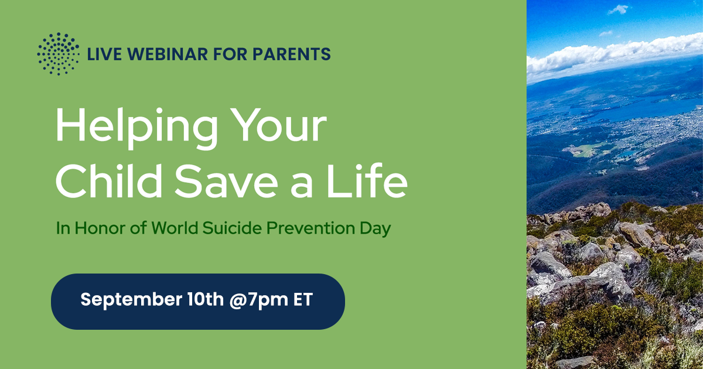
    - September 23rd at 1pm
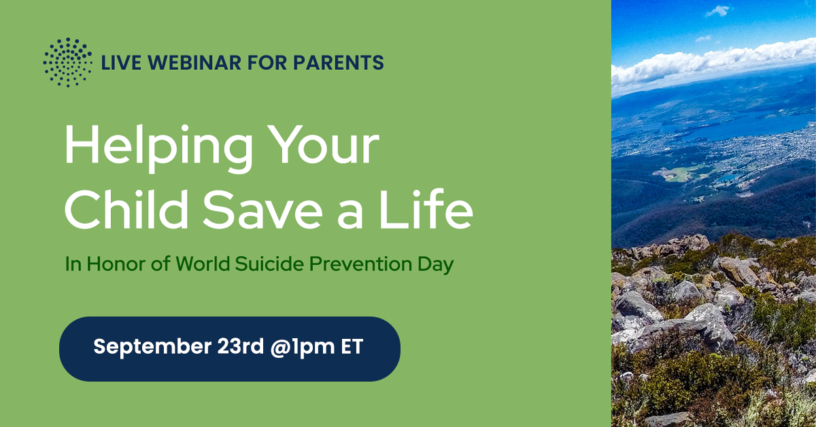
- American Foundation for Suicide Prevention (AFSP)
  - #KeepGoing campaign: Webinars and events to advance knowledge of suicide prevention throughout the month:
    - September 10th, Allies in Action Awards Event: Join AFSP as they present the Sandy Martin Field Advocates of the Year, Allies in Action, Perspicacity Awards, and the Innovations in Suicide Prevention Awards. The event will feature remarks from members of Congress and a keynote presentation from David Wasserman who will provide an outlook on the Presidential and Congressional races this November. Register here.
    - September 14th, Mental Health & Suicide Prevention in the Era of COVID-19 webinar: Join representatives from AFSP, the Action Alliance, the Center for Law and Social Policy, and Recovery Innovations International as we discuss necessary reform in mental health parity, crisis lines, and health systems. Register here.
    - September 22nd, K-12 Suicide Prevention Policies for Back to School webinar: Learn about the federal and state policies and legislation that can prevent suicide and support positive mental health in the K-12 school setting. Register here.
  - List of all their events
https://afsp.org/keepgoing/#national-suicide-prevention-week-events-calendar
  - Articles:
    - I’m Your Canvas: Four Tips on How to Have a #RealConvo with a Friend https://afsp.org/story/i-m-your-canvas-four-tips-on-how-to-have-a-realconvo-with-a-friend
    - Video Tips on How to Have a #RealConvo About Mental Health
https://afsp.org/story/video-tips-on-how-to-have-a-realconvo-about-mental-health
    - 9 Suggestions for Other Parents Who Have Lost a Child to Suicide
https://afsp.org/story/9-suggestions-for-other-parents-who-have-lost-a-child-to-suicide
  - Images:
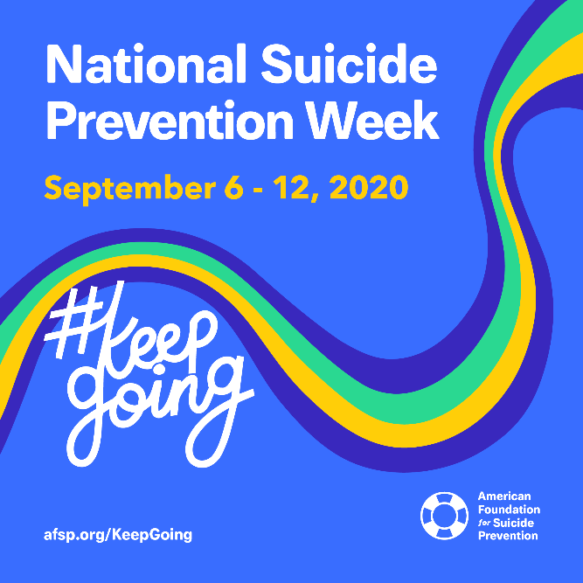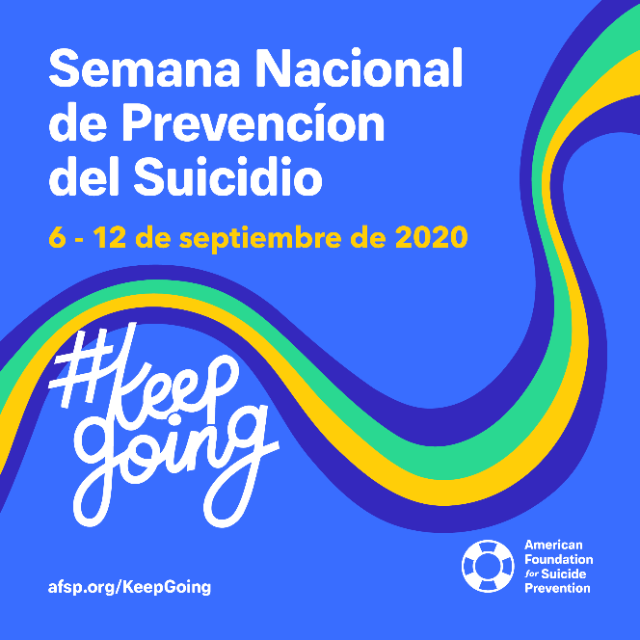
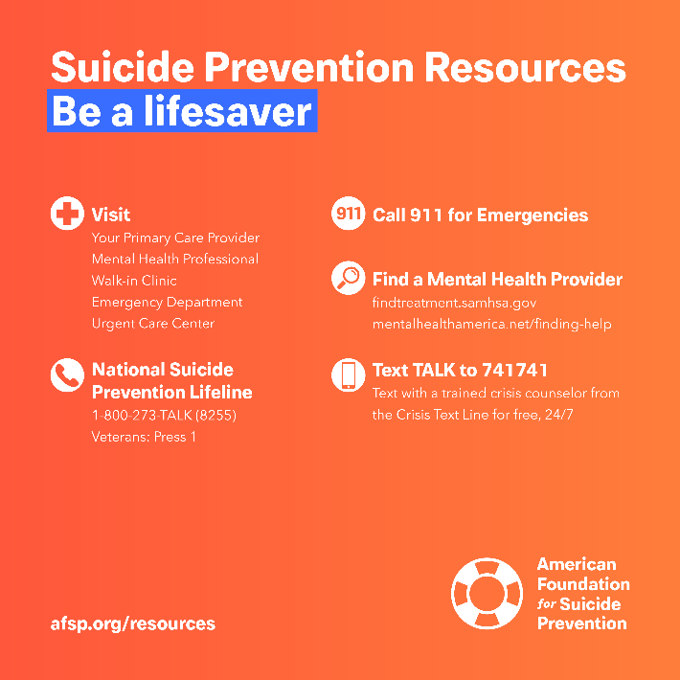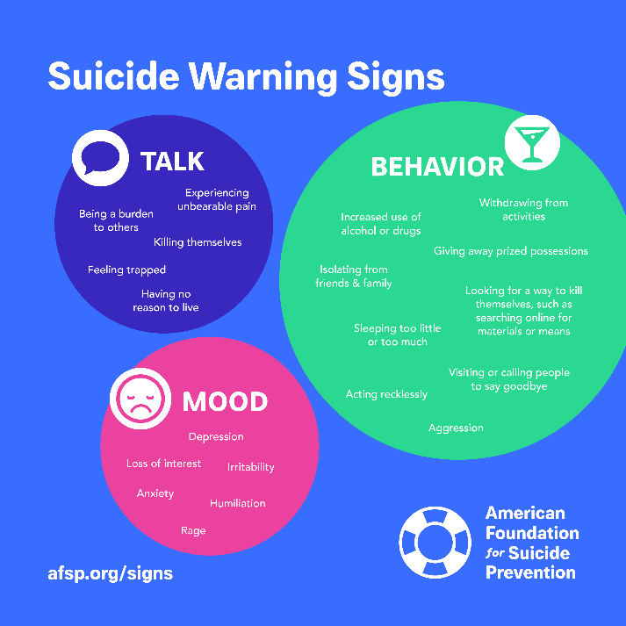
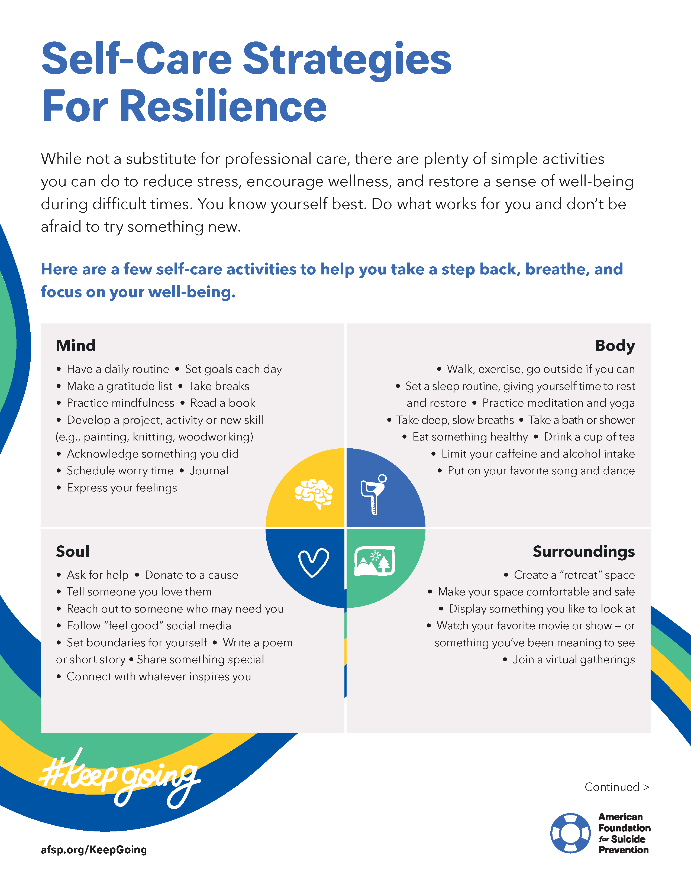
- American Association of Suicidology (AAS)
  - #AAS365 #BeThere Campaign: “For 2020, AAS wants to know what suicidology means to you. Does it mean connection? Does it mean an increased focus on a particular kind of research? Does it mean creating a life worth living? We want to hear from you – send us your videos, songs, art, drawing, poems, essays, however you can express what suicidology means to you – and we’ll post your creations here. Post on social media what suicidology means to you and use the hashtag #AAS356 or #SuicidologyIs and we’ll make sure to share your content.” Source: https://www.aas365.org/
  - List of all their Events: https://www.aas365.org/new-events
- Suicide Prevention Lifeline

  - #BeThe1To Campaign: https://suicidepreventionlifeline.org/promote-national-suicide-prevention-month/
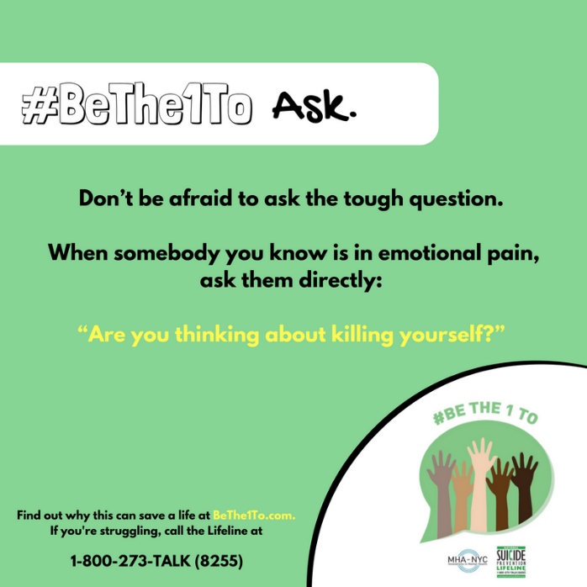 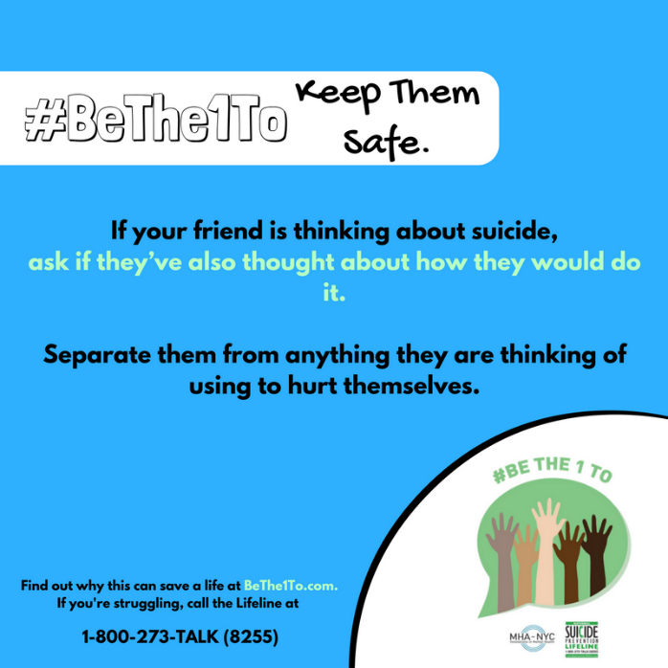
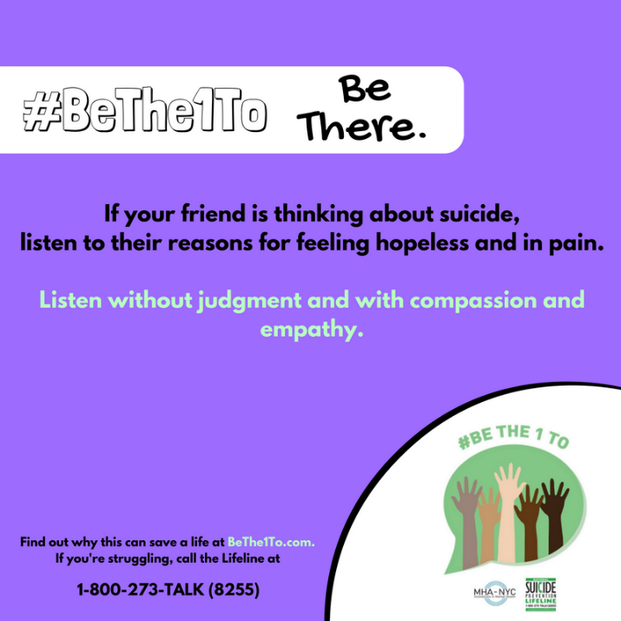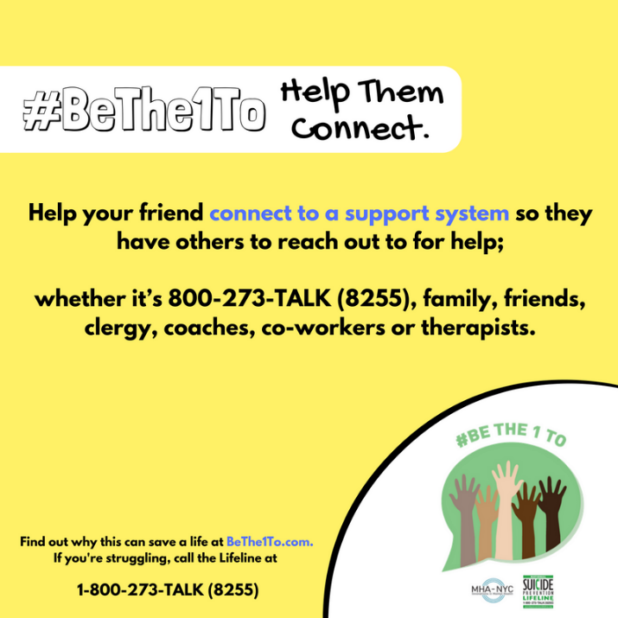
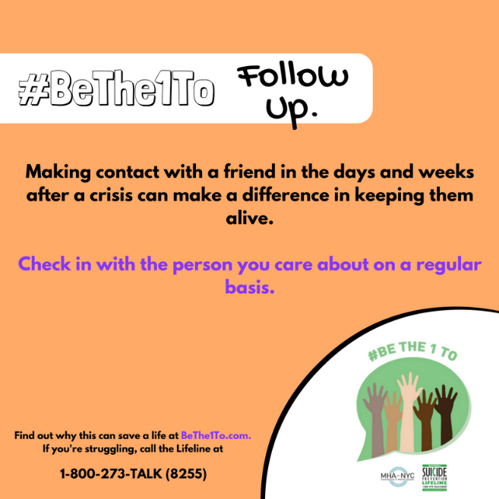
- Suicide Prevention Resource Center (SPRC)
  - Suicide Prevention Month Ideas for Action https://www.sprc.org/sites/default/files/Suicide%20Prevention%20Month%20Ideas%20for%20Action%202020.pdf
- International Association for Suicide Prevention
  - World Suicide Prevention Day
https://www.iasp.info/wspd/pdf/2020/2020_wspd_infographic.pdf
  - Suggested Activities
https://www.iasp.info/wspd/pdf/2020/2020_wspd_suggested_activities.pdf
  - Take a Minute
https://www.iasp.info/wspd/pdf/2020/2020_wspd_take_a_minute.pdf

